**Devops CS451 – Assignment Task 4**

**Ansible lifeline examples – Add, Modify, Delete, and Replace lines….**

Ansible lineinfile module is **used to insert a line, modify, remove, and replace an existing line**. ... Ansible lineinfile provides many parameters to do the job quickly. You can also use the condition to match the line before modifying, removing using the regular expressions.

To install Ansible run these commands in Ubuntu

$ sudo apt-get update

$ sudo apt-get install software-properties-common

$ sudo apt-add-repository ppa:ansible/ansible

$ sudo apt-get update

$ sudo apt-get install ansible -y

1. **To check if a line is present in the file and return the line**

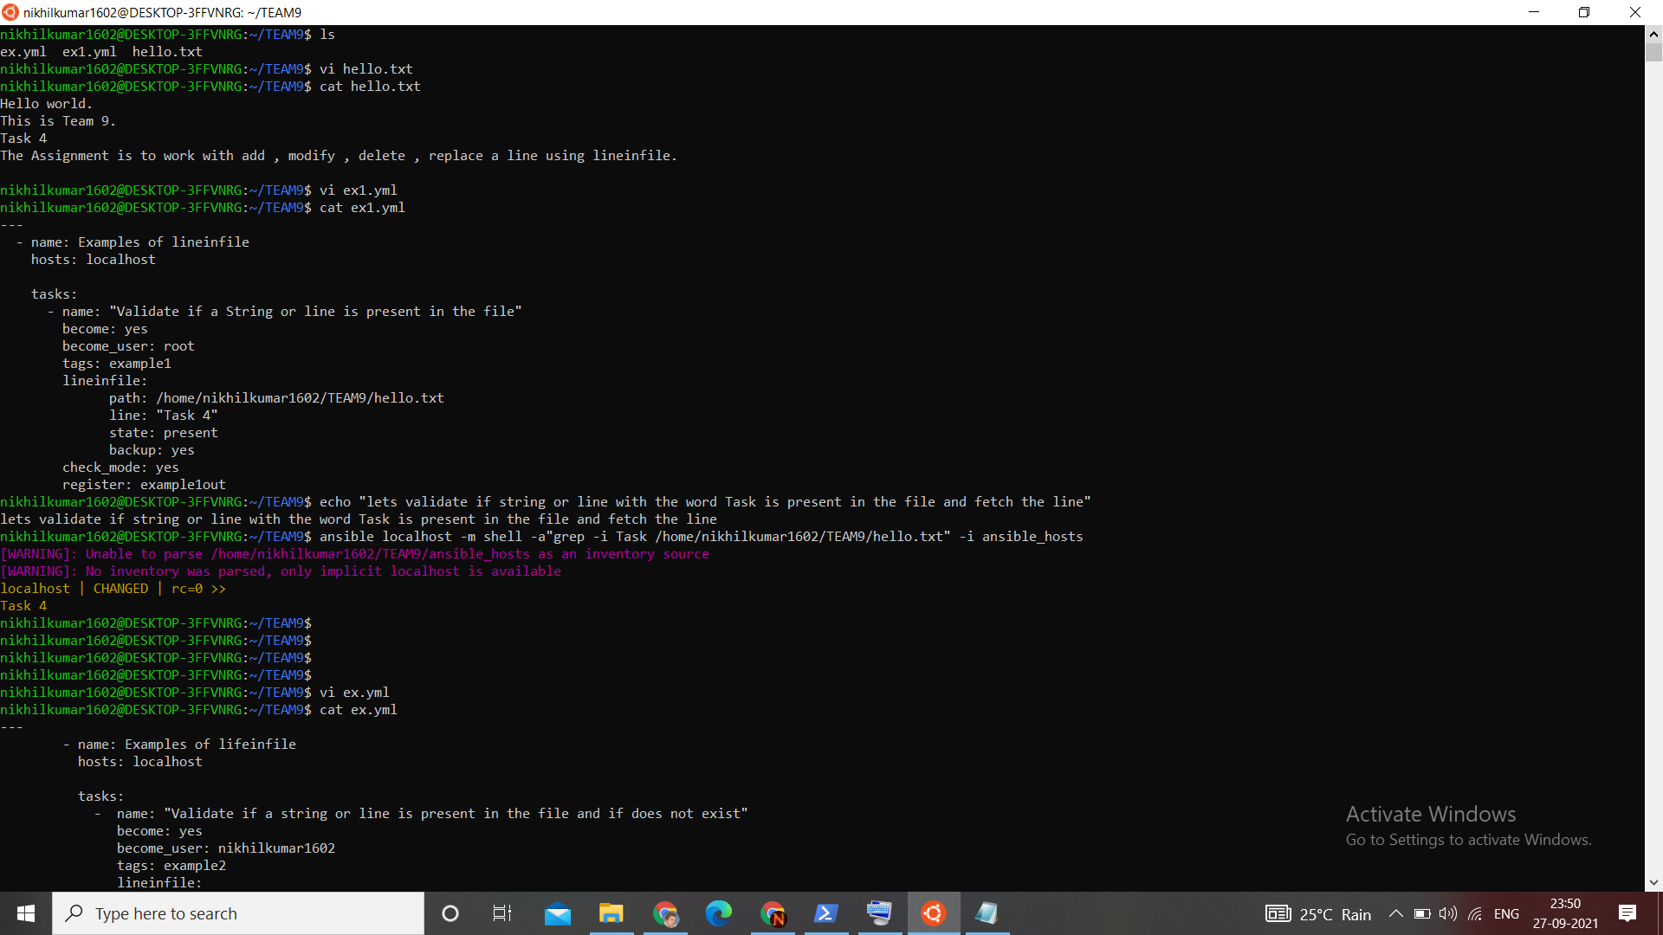

It just checks if line is present or not and returns, it does not modify…

1. **To check if a string is present in the file , if not add it**

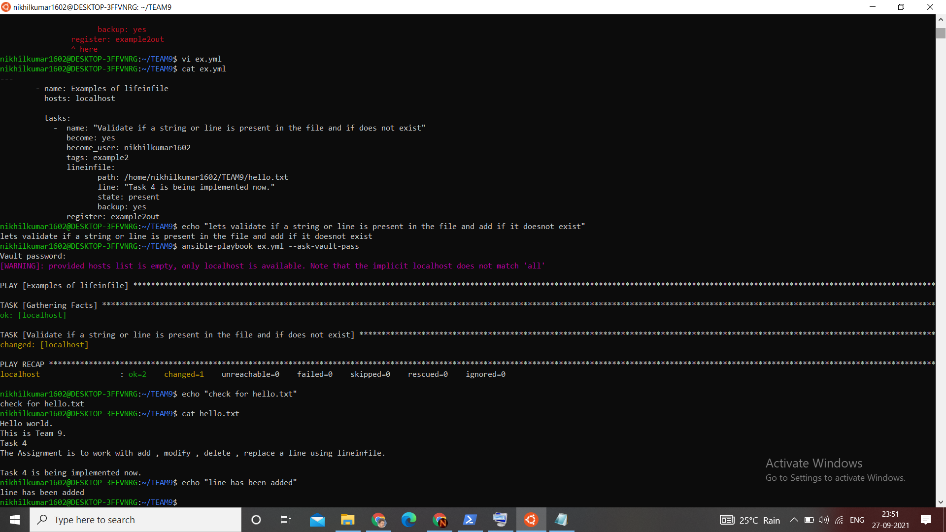

Ansible Play book will look up for a line and adds it when, none of the lines matches…….

And the line will be added to the end of the line or at last..

1. **To replace a line**

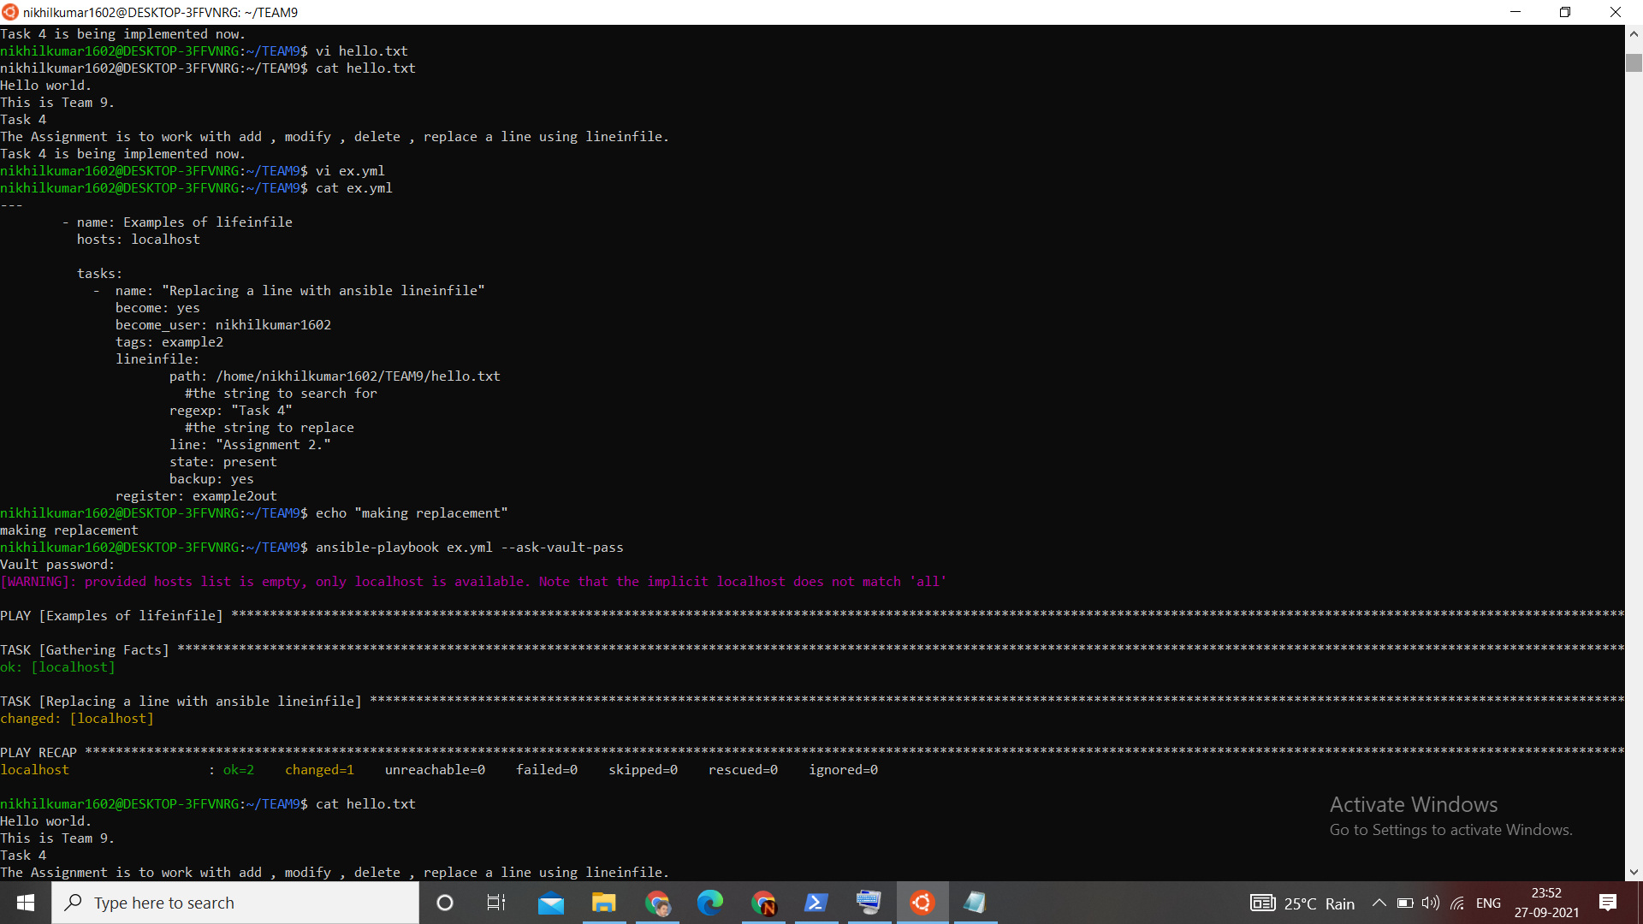

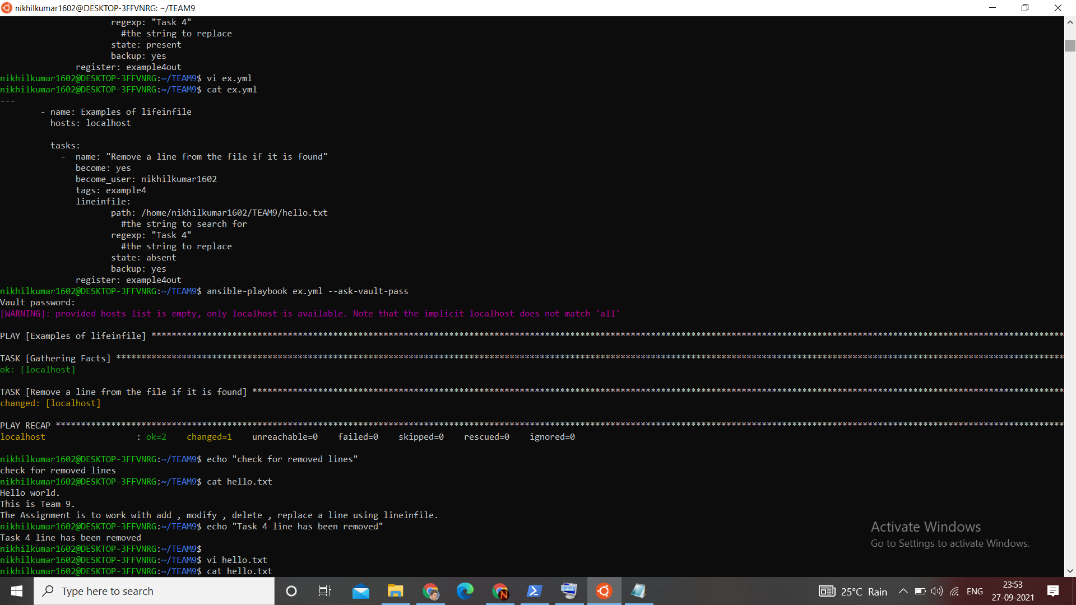

Using regexp – regular expressions to search and replace

1. **To check if a line is present and remove it**

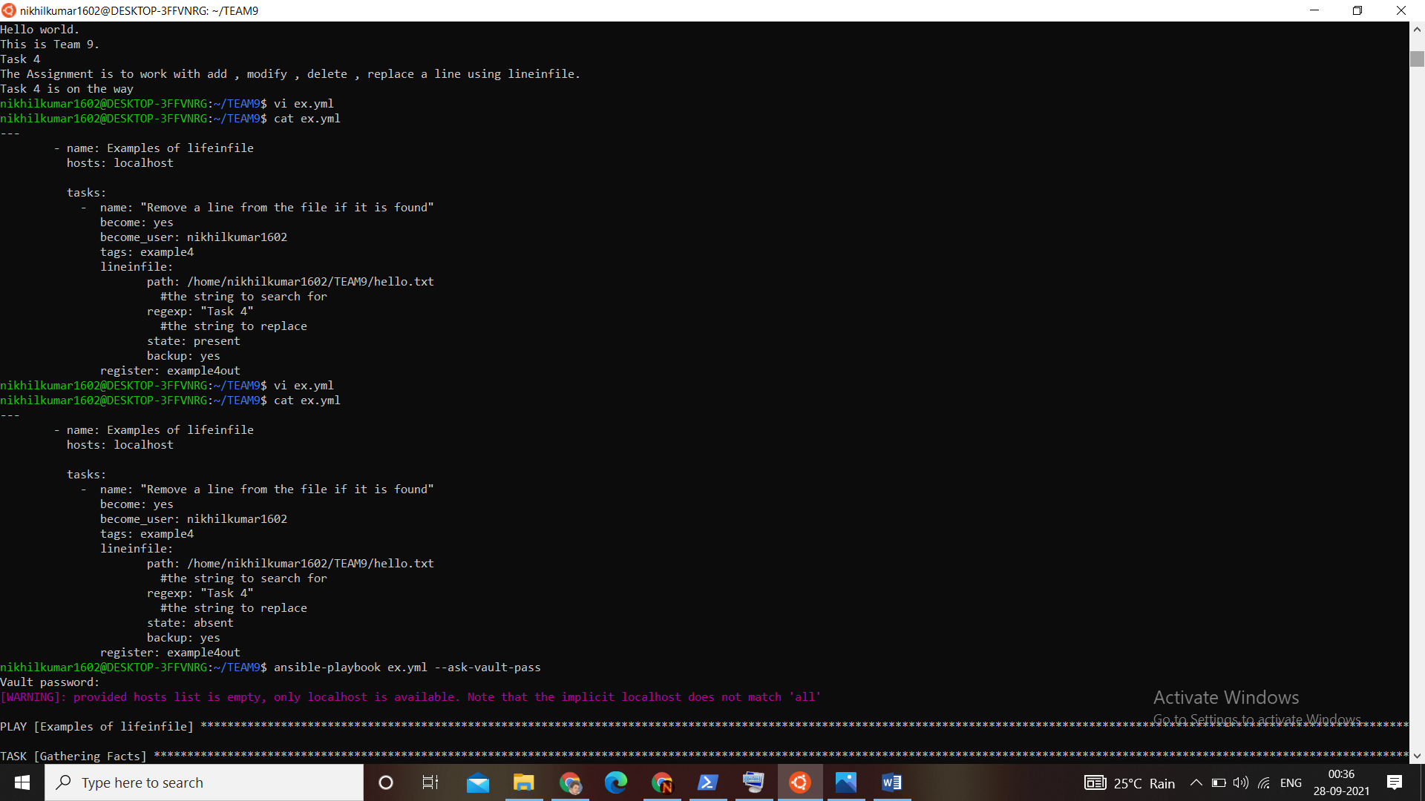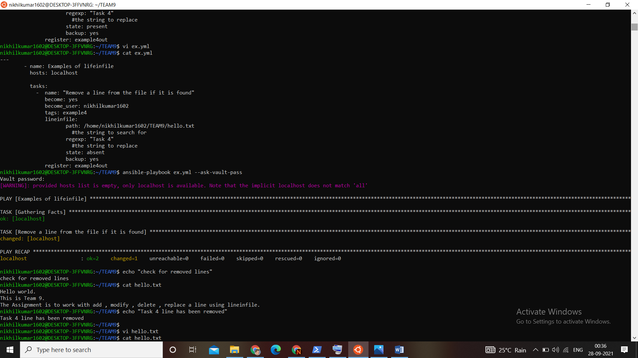

All expressions matching regexp will be removed

1. **Inserting line after a matched line**

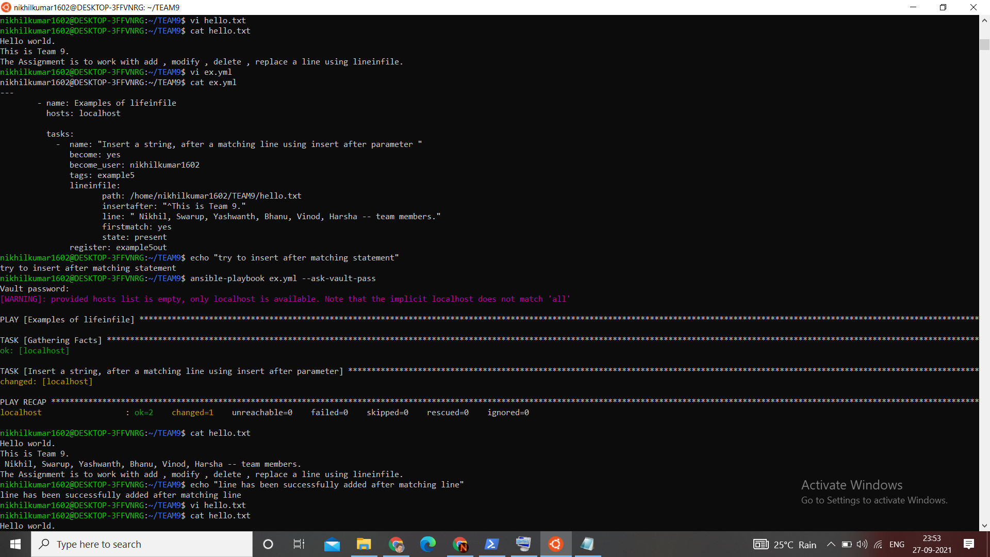

Insertafter is used find the matched line her and adds a line after it

If there are many elements matching the line then it will insert after the last line.

1. **To comment a line**

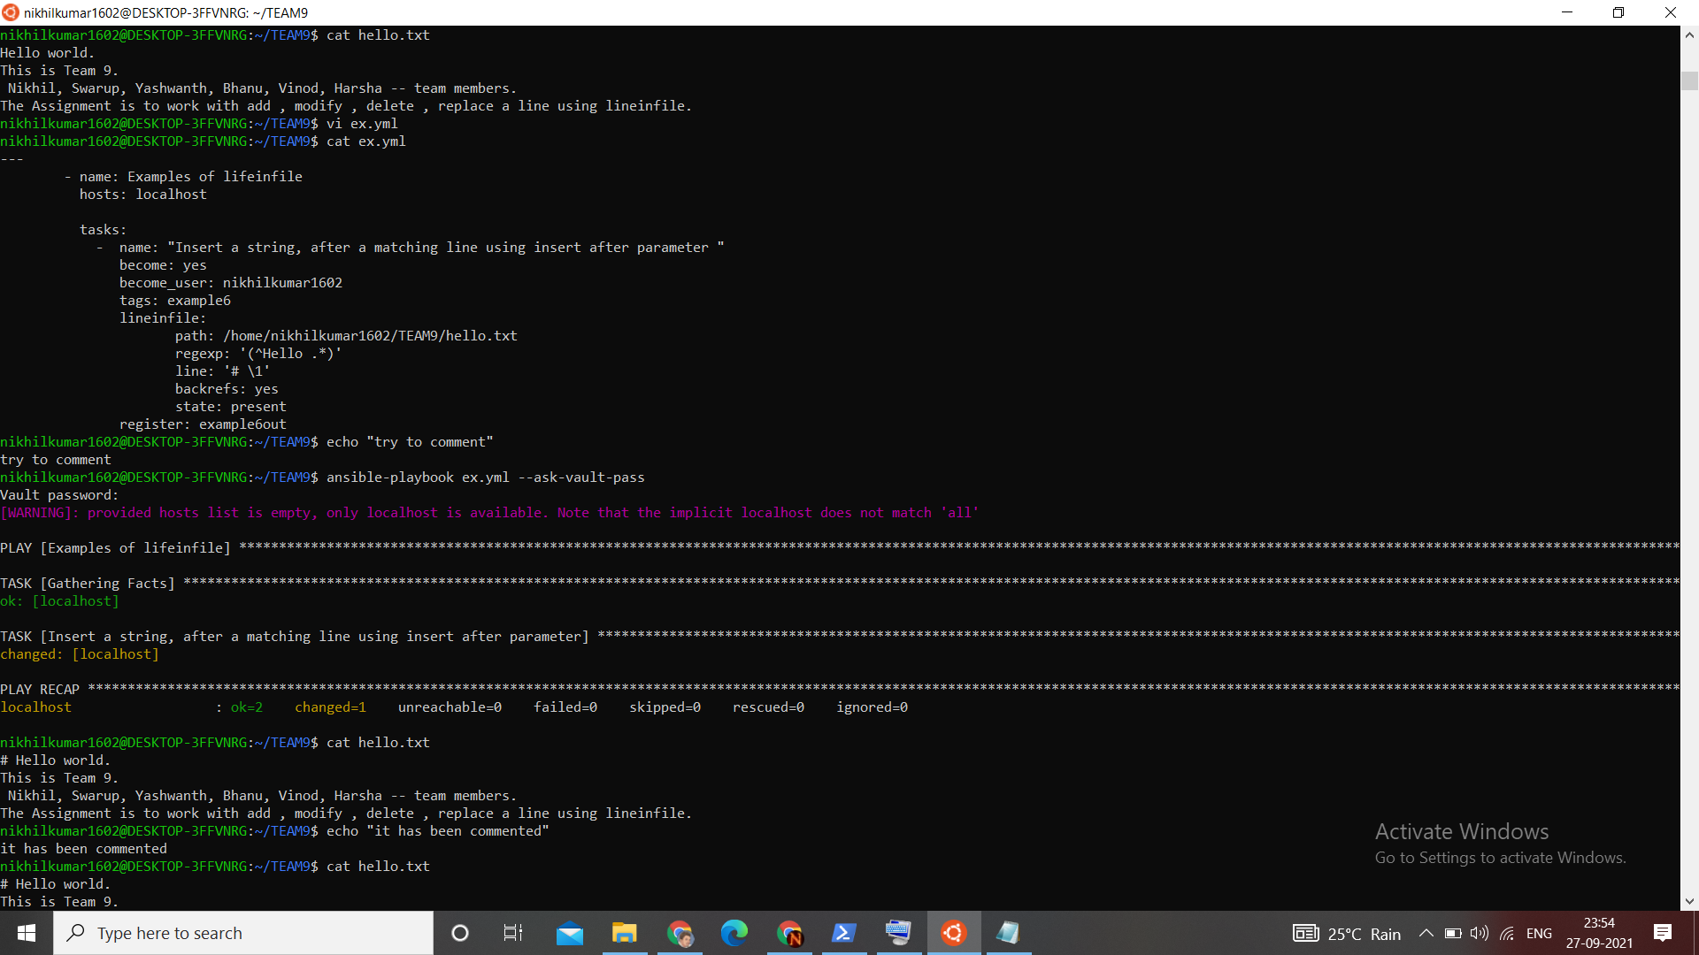

1. **Replacing multiple lines**

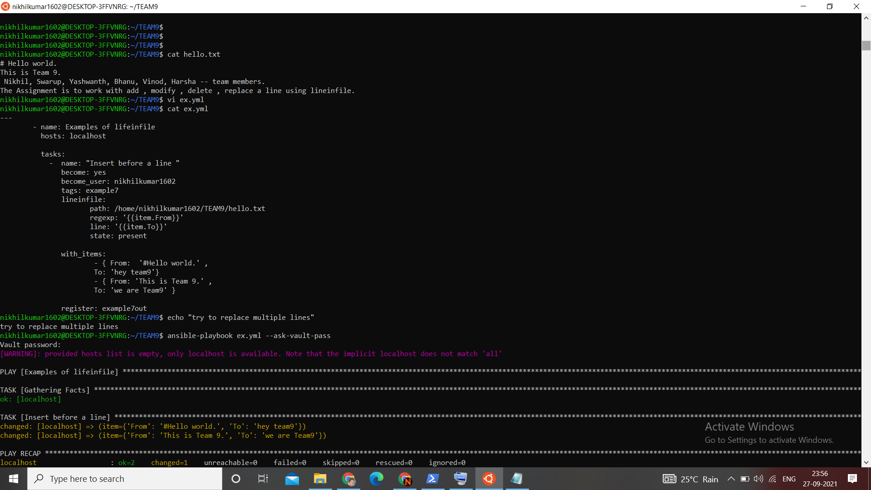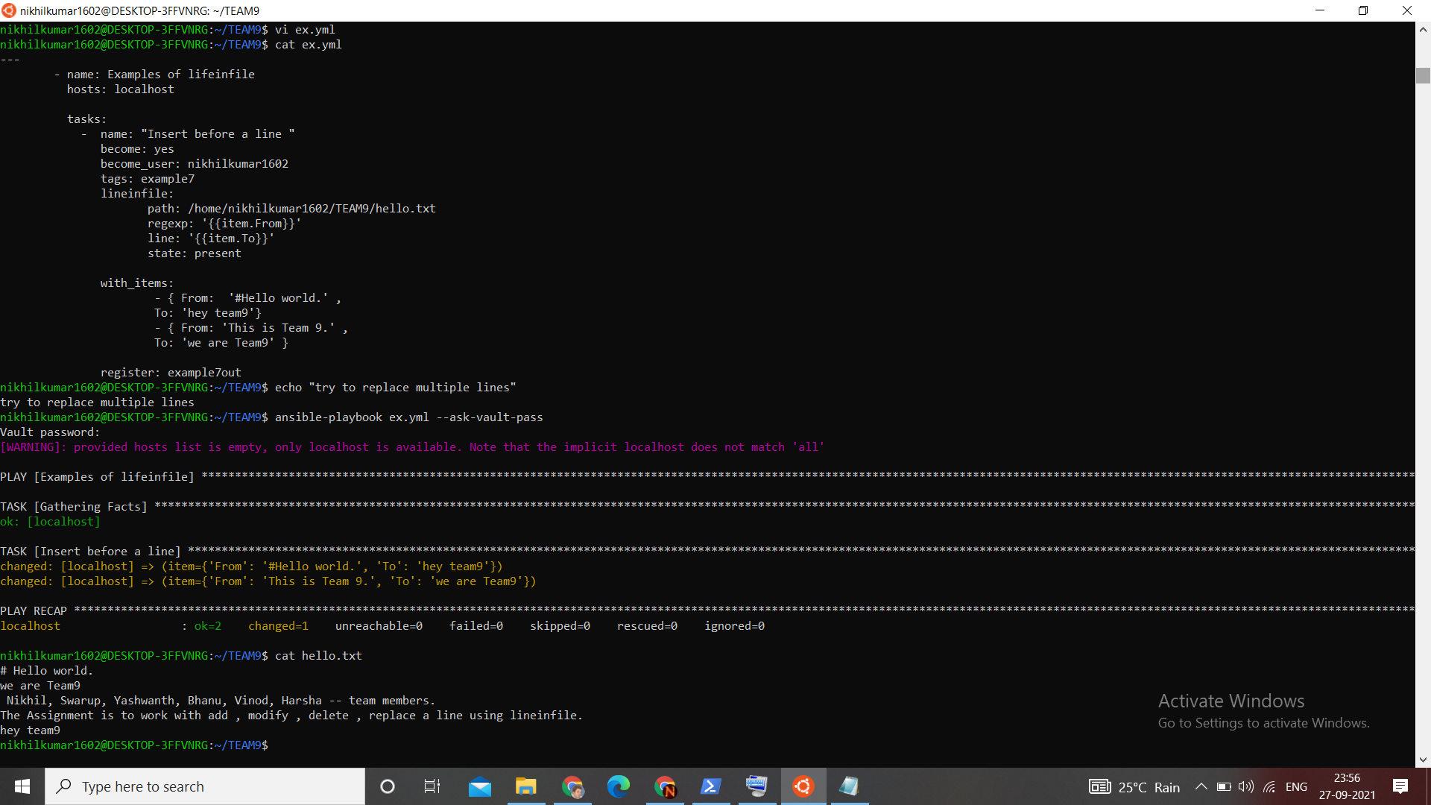

We used with_items to pass multiple values to regex…

**By Team 9**

**N Nikhil Kumar 18bec031 | K Yashwanth 18bec020**

**P Bhanu Prakash 18bec035 | M Vinod 18bec027**

**Y Santhi Swarup 18bec051 | V Harsha Vardhan 18bcs118**